GLASS SKIN
Glass Point Workshop ISGNE project
11-16.03.2019
Artist Gracia Nash
To open our minds and souls, Glass Point studio invites to experience multi-media and glass artist Gracie’s workshop. Participants will explore a new way of creating small-scale glass sculpture through the combination of flameworking (borosilicate) and glass fusing (soft glass). Sculptures will be built up by attaching small sheets of fused frit onto a flame worked internal structure. Participants will learn basic flameworking and fusing techniques and share their final pieces in a pop-up exhibition at the end of the class.

ARTIST GRACIA NASH
Gracia Nash is a glass and multi-media artist based out of Rochester, New York. She graduated from the New York State College of Ceramics at Alfred University in 2014 with a Bachelor of Fine Art. She is currently a Master of Fine Arts in Glass candidate at the School for American Crafts at Rochester Institute of Technology, exploring the aesthetic and conceptual possibilities of glass, while maintaining a sense of play and appreciation for material and process.

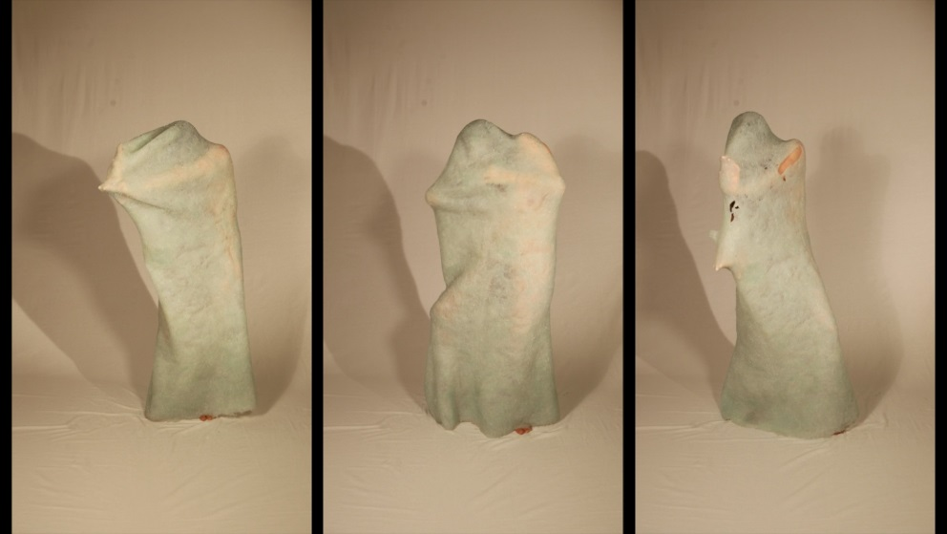
“PUSH” Silicone, Glass Beads, Body Performance Stills from Video. 2018
ARTIST STATEMENT:

I utilize glass to explore identity in relation to constructs of home, place, and relationships. The materiality of glass drives my work through the conceptual dualities that it possesses; fragility and strength, opacity and transparency, reflective and matte. I use these qualities to contextualize my ideas. I am interested in how one’s identity is formulated and altered through the experiences and memories of the places we live, and the people we surround ourselves with. I find inspiration through my own experiences, and the research of material and process. My family and the relationships I experience - either my own or between those around me - are also sources of inspiration. I am interested in embodying the varying definitions of identity and the dynamics of relationships through sculpture, performance, and installation, and I create as a way of understanding these dynamics.

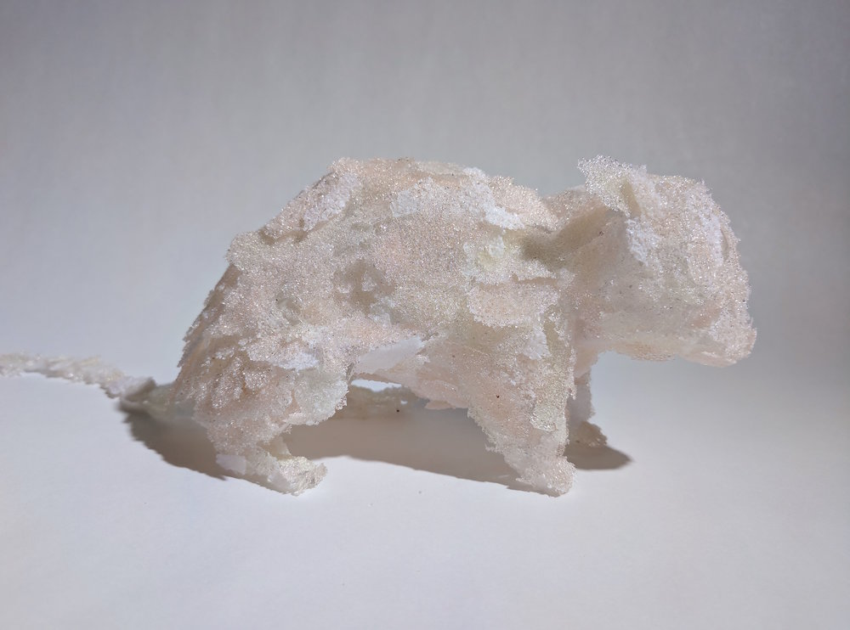
“STASIS” 61 x 130 x 10 cm Fused and Flameworked Glass 2017
PROGRAM 11-16.03.2019
Place for the Visiting artist Master class – Glass Point studio, Pernavas 33, Riga, Latvia

Day One: March 11th
11.00 Presentation by artist “GRACIA NASH/ creative process”
12.00 Coffee Break
12.30 Get to know participants.
13.30 Sketching, brainstorming - artists presence.
15.00 Individual discussions with Gracia Nash. Project Plans - Pick colors/themes

Day Two: March 12th
Making the base structure (under 15cm)
Demo of simple Flameworking Structure, loading kiln to create fused sheets.

Day Three: March 13 th
Make, make, make!
Work with the material – flamework, fusing frits.
Adding the frits to the base structure

Day Four: March 14 th
Work with the material

Day Five: March 15 th
Work with the material, assambling sculpture. Pop-up exhibition setup.

Day Six: March 16 th
11.00 Final things that needs to be done before the opening

14.00 Pop - up exhibition with the works created!

ISGNE project
The ISGNE project will run from 2018 - 2022 and will look to make the medium of glass more accessible to a non-arts audience, bringing to the fore a wider public debate on the sustainability of contemporary glass by a program of ambitious and unique experiences.

Creative Europe
The Creative Europe program aims to support the European audiovisual, cultural and creative sector. By helping European cultural and audiovisual works to reach audiences in other countries, the program will also contribute to safeguarding cultural and linguistic diversity.
COFINANCED BY REBUBLIC OF LATVIA MINISTRY OF CULTURE
PROJECT SUPPORTED BY EU - THE CREATIVE EUROPE PROGRAM
PROJECT TITLE, IMAGINING SUSTAINABLE GLASS NETWORK, EUROPE - ISGNE

More Information - Anna Varnase
Project ISGNE coordinator Latvia
anna@glass-point.eu
Phone +371 28288529

APPLY NOW!
Send us an e-mail to
info@glass-point.eu
Include your name / surname / phone number

Fee for 6 day long workshop – all materials included 350,- €
COFINANCED BY REBUBLIC OF LATVIA MINISTRY OF CULTURE
PROJECT SUPPORTED BY EU - THE CREATIVE EUROPE PROGRAM
PROJECT IMAGINING SUSTAINABLE GLASS NETWORK EUROPE - ISGNE
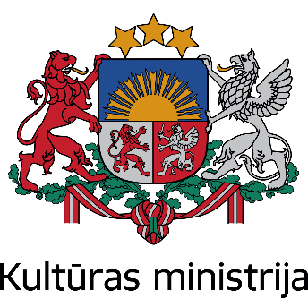
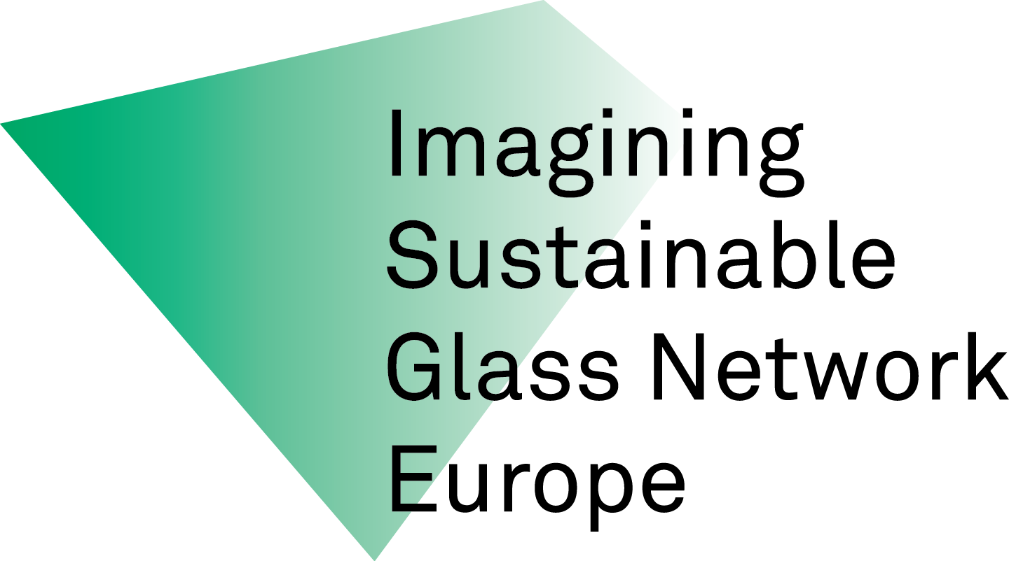

COFINANCED BY REBUBLIC OF LATVIA MINISTRY OF CULTURE
PROJECT SUPPORTED BY EU - THE CREATIVE EUROPE PROGRAM PROJECT
IMAGINING SUSTAINABLE GLASS NETWORK, EUROPE - ISGNE

